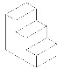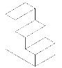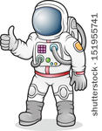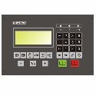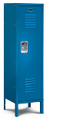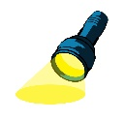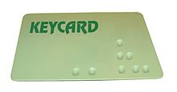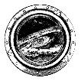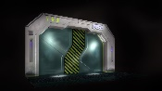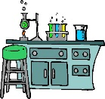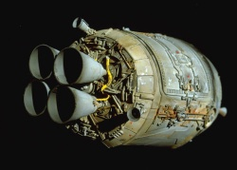

Airlock

**Purpose**: Enter Escape Pod; Trap

**Items**: Big Red “LAUNCH” Button

**Can Enter**: Escape Pod

**Puzzle**: Enter Escape Pod before pressing LAUNCH button

**Possible Game Over**: If you press LAUNCH button prior to entering the Escape Pod

Escape Pod

**END GAME HERE**

**Purpose**: Final Room

**Items**: Big Red “LAUNCH” Button, Control Panel with Empty key hole and four buttons

**Can Enter**: N/A

**Puzzle**: Final Puzzle – User must *use* LAUNCH button, press buttons in correct order (as found in the two clues – 3, 4, 1, 2, 1, 1, 4, 2), then *Use* the blue key to successfully navigate to Earth

**Possible Game Over**: If you press LAUNCH button prior to entering the Escape Pod; Enter final sequence in wrong order

Storage

**Purpose**: Obtain Key for Escape Pod

**Items**: Headset, Red Key, Blue Key, Green Key

**Can Enter**: Research & Development, Airlock (Requires Keycard)

**Puzzle**: *Use* Flashlight to reveal keys and their colors; *interact* with the correct key (Blue, as learned from clue in Research & Development)

**Possible Game Over**: If death counter activated and reaches 5 before using Medical Kit

Research & Development

**Purpose**: Obtain other half of Escape Pod Instructions

**Items**: Headset

**Can Enter**: Emergency Stairs, Storage

**Puzzle**: *Look* at voice to reveal headset; *interact* with headset to receive rest of Escape Pod Instructions

**Possible Game Over**: If death counter activated and reaches 5 before using Medical Kit

Recreation Room

**Purpose**: Contains Keycard for unlocking Airlock; Navigation between rooms

**Items**: Keycard (Must reveal by using flashlight), Window

**Can Enter**: Command Room, Medical Facility. Emergency Stairs

**Puzzle**: Use Flashlight to reveal Keycard; *Interact* with to add to inventory

**Possible Game Over**: If death counter activated and reaches 5 before using Medical Kit; Interact with window

Emergency Stairs

**Purpose**: Navigation between rooms

**Items**: None

**Can Enter**: Recreation Room, Research & Development

**Possible Game Over**: If death counter activated and reaches 5 before using Medical Kit

Crew Quarters

**Purpose**: Acquire Flashlight for future puzzles

**Items**: Locker (Contains Flashlight and gun)

**Can Enter**: Command Room

**Puzzles:** User *interact* with locker to add flashlight and gun to inventory

**Possible Game Over:** Death Counter Reaches 5 (if activated) before using Medical Kit

Command Room **GAME START**

**Purpose**: Starting Room; First puzzle; Acquire suit

**Items**: Space Suit

**Can Enter**: Crew Quarters, Recreation Room

**Puzzle**: Interacting with suit must be first command

**Possible Game Over**: If putting space suit on is not first command; Death counter reaches 5 (if activated) before using Medical Kit

Medical Facility

**Purpose**: To obtain Medical Kit (for use when monster hurts you)

**Items**: Medical Kit

**Can Enter**: Recreation Room, Cryogenic Lab

**Puzzle**: *Look* at counter to reveal Medical Kit; *interact* with to add to inventory

**Possible Game Over**: If death counter activated and reaches 5 before using Medical Kit

Cryogenic Lab

**Purpose**: Monster Attack; Kill monster; obtain first half of Escape Pod Instructions; Death Time Started due to monster hurting you (5 commands without “*use* Medical Kit = Game Over)

**Items**: Escape Pod Instructions (first half); Monster

**Items Used**: Gun, Medical Kit

**Can Enter**: Medical Facility

**Puzzles**: *Use* Flashlight to reveal monster; *Use* gun as first command after seeing the monster; *Look/Interact* at Escape Pod Instructions in order to receive message with first part of escape code

**Possible Game Over**: If command after seeing monster is not “*use* gun”; Death timer runs out before using Medical Kit